Flexible Working Application Form
Guidance for you
Prior to completing the form you should refer to the Flexible Working Policy on the HR Gateway for detailed information.
http://ofgemintranet/EmployeeEssentials/PayPensionsBenefits/Benefits/Pages/FlexibleWorking.aspx
Please use this form to request flexible working and ensure that you complete Section A of the form fully to assist your line manager to make a considered decision. Once you have completed the form please send it to your line manager with a copy to your HR Officer.
If your request is approved it will normally represent a permanent change to your terms and conditions and HR will confirm the changes in writing to you.
If your request is refused, you will have the right of appeal against the decision and you can find details of this in the Flexible Working Policy.
Guidance for the line manager
This is a formal application for flexible working and needs to be considered in line with Ofgem’s Flexible Working Policy on the HR Gateway. You are required to discuss this application with the member of staff and complete Section B. Once completed please forward the form to HR who will write to the member of staff confirming your decision and any changes to their contract of employment.
Section A
Your Details
Name: | Liz Johnston
Directorate: | A&A - DDI
Line Manager: | Rory McCabe
Date: | 26/04/2021
Date of any previous request for a change to work pattern: (if applicable) | N/A
Describe your current working pattern (days/hours/times worked):
Stand Ofgem Glasgow contract 5 days (Mon – Fri), 37 hours per week

Describe the working pattern you would like to work in future (days/hours/times worked) by completing the table below. It is a legal requirement that you take a minimum break of 30 minutes if you work 6 hours or more in any given period.
Please note that if you are requesting to work from home you must also complete the Health and Safety Self Assessment Form.
Week1:
Day | Start Time | End Time | Lunch Break (ie.30 minutes/1 hour | Total Working Hours Excluding Lunch Break | Comments, including if Working from Home or a Non-Working Day
Monday | 09:00 | 18:00 | 40 | 8:33
Tuesday | 09:00 | 18:00 | 40 | 8:33
Wednesday | 09:00 | 17:00 | 40 | 7.33 | Kayaking
Thursday | 09:00 | 18:00 | 40 | 8:33
Friday | 09:00 | 18:00 | 40 | 8:33
40:67

Total Hours Worked Each Week:
Week2:
Day | Start Time | End Time | Lunch Break (ie.30 minutes/1 hour | Total Working Hours Excluding Lunch Break | Comments, including if Working from Home or a Non-Working Day
Monday | 09:00 | 18:00 | 40 | 8:33
Tuesday | 09:00 | 18:00 | 40 | 8:33
Wednesday | Non-Working Day / can be swapped to another day if work demands
Thursday | 09:00 | 18:00 | 40 | 8:33
Friday | 09:00 | 18:00 | 40 | 8:33
33:33
Total Hours Worked Each Week:
Total Hours Worked Over 2 Weeks: 74:00
Your annual leave will be calculated in hours.
If you will be working compressed hours over two a week period, please complete a separate table for the second week, again confirming the hours to be worked that week.
I would like this working pattern to commence from:
01/06/2021

Please note the effective date will be classed as week one, unless otherwise advised and may affect how your annual leave is allocated.

Impact of the new working pattern - I think this change in my working pattern will affect Ofgem and my colleagues as follows:
Work is task based so should not impact others in the team or Ofgem. Contact with business users and team members in relation to work can be scheduled to match working pattern.

Accommodating the new working pattern - I think the effect on Ofgem and my colleagues can be dealt with as follows:
Schedule any required meetings, contacts to match working pattern.
Where required can swap non-working day to meet business demands.
Ensure team and Ofgem calendar is kept up-to-date including non-working days

Please provide any further information that will support your application:
Having an extra free day every 2 weeks will allow me to better manage my family obligations, particularly my visits to support my mother which keep me up way too late!

Your Signature: Date: 26/04/2021
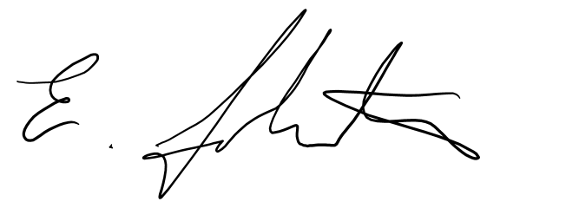

Please forward this application to your line manager for consideration.

Section B
For completion by line manager
If you approve the request, you should confirm the arrangements and start date in the space below.
If you refuse a request, you must do so based on the permitted statutory reasons which are:
- planned structural changes
- the burden of additional costs
- a detrimental impact on quality
- the inability to recruit additional staff
- a detrimental impact on performance
- the inability to reorganise work among existing staff
- a detrimental effect on ability to meet customer demand
- lack of work during the periods the employee proposes to work

Please provide your reasons for approving or refusing this request:
Discussed with Steven Steer and HR - Approved

Your Name: Rory McCabe
Signature: 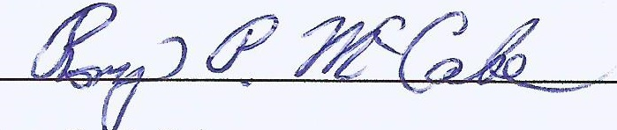 Date: 30th April 2021
Please forward this application to HR.

